Digital Technology and Wilderness

Table of Contents

1. Who’s on the trail? Identifying trail users 3

2. Types of technology use or non-use before, during and after a hike and their impact on user experience 4

2.1. Before the hike: 4

2.2. During the hike: 4

2.2.1. Social Theme: 4

2.2.2. Navigation Theme: 5

2.2.3. Fitness Theme: 6

2.3. After the hike: 7

3. Park/trail managers and the use of digital technology/ motivations/ information they would like 7

3.1. GIS coverage and application: 7

3.1.1. Planning and Engineering: 7

3.1.2. Operational Efficiency: 7

3.1.3. Data Driven Performance: 8

3.1.4. Civic Inclusion: 8

3.2. Community based information: 8

3.3. Digitization websites: 8

4. Bibliography: 9

# Who’s on the trail? Identifying trail users

Hiking as a recreational activity is perceived in various perspectives according to different hikers’ points of interest (POI), such as; exercise, meditation, in search of individual meaning (Berg, 2015) or disconnecting from daily stresses (Mills and Butler, 2005). However, a common interest is connecting with nature. With the rise of technology and the over-reliance on smart phones, this has created both opportunities and threats for hiking as an experience. There are two opposing views on the relation between technology and hiking. In order to achieve a comprehensive understanding of hikers’ views and attitudes towards technology preferences on the trail, several researchers have tried to cluster hikers into different user groups. While some researchers focused on clustering the hikers based on quantitative methods using K-cluster algorithm with a focus on age groups and number of preferred activities on the trail to identify different personas, where younger personas were more likely to carry more than 3 gadgets and depend on phone GPS while older clusters brought less technology and relied on paper maps along with their GPS (Kondur, 2018). Other researchers have focused on identifying various groups on the trail from transient users to community inhabitants depending on their occupation and reason to be on the trail, some of the groups arising from this classification where the thru-hikers who preferred the use of hiking apps and social media to share experiences with families at home and plan meet ups with fellow hikers, another example were joggers who preferred using their headphones to avoid other hikers (Kotut et al, 2020). Another approach identified groups based on the hiking type; day hikers, multiday hikers, section hikers and thru hikers. The final approach was dividing hikers based on the frequency and motivations such as tourists or hiking enthusiasts or hikers who prefer shorter hikes, where hiking club (people opting for shorter hikes) were more likely to use fitbit (22%) than meditators who prefer solitude and are more likely to use their headphones (37%) (Anderson et al, 2017). According to Goldenberg et al (2008), identifying the needs and technology use for the different types of users is an important first step.

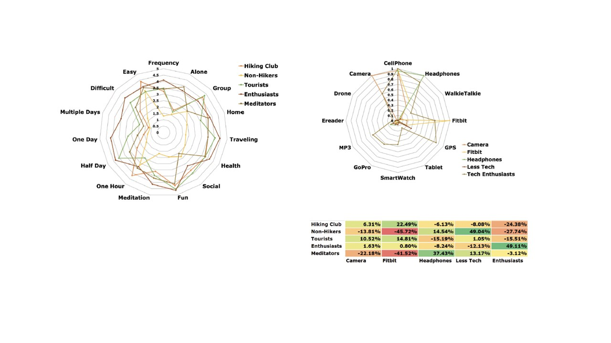

Fig 1. shows 5 clusters of hiking identified by K-means of clustering (left), five clusters of technology preferences identified by k-means clustering (top right) and differences in probabilities belonging to each tech cluster given a hiking cluster (bottom right) (Anderson et al, 2017)

# Types of technology use or non-use before, during and after a hike and their impact on user experience

This report aims to study the role of technology use or non-use on the trail and how this affects the hiking experience. Technology use has a temporal dimension to it (McCarthy and Wright, 2004). It can be used to affect the different users’ experience before a hike which helps with preparing for a hike, during which aids the trail experience and after where hikers can reflect on their experience. According to a quantitative survey, 95% of respondents bring a smartphone during a hike (Anderson et al, 2020).

## Before the hike:

Various information was needed for planning a hike, from planning the route of travel to checking local weather forecast, lodges and information on public transport in the area (Annu-Maaria Nivala et al., 2009). While this information aids the planning experience of the hike, several criticisms were made; among which are the limited availability of information for special user groups such as people with disabilities (Annu-Maaria Nivala et al., 2009). According to Hyatt et al (2020), the rise of technology while it may be rewarding, it also invites risk and this is evident in his analysis where he discusses the rise of solo and off-trail journeys and the possible access to fragile areas. The author also mentions that the use of physical maps has greatly declined where only 4% plan their routes using physical maps, 37.9% use exclusively digital maps and 58.9% use a mix of both methods. The younger groups mostly rely on digital maps, which is also evident in Kondur’s research (2018). Interestingly, a lot of hikers had anxiety about battery power management for their devices and have also planned by checking areas for battery charging and downloaded maps. Although digital technologies aid hikers’ preparedness, safety guidelines for hiking such as HikeSafe discouraged users from the overreliance on digital maps and have promoted the use of paper maps to avoid issues regarding poor signal and battery power problems.

## During the hike:

There are several user requirements for technology during a hike. These can be classified into 3 themes; the first theme is social which includes sharing and saving experiences and sometimes involve location services such as sharing location with other hikers for planned meetups. The other theme is navigation and tracking which includes location, integrative adaptive services, changing conditions and emergency services. The last theme is fitness which includes specific technology geared towards this goal.

### Social Theme:

The social theme is linked to saving experiences involve blogging and saving video or voice recording diaries, taking pictures and saving GPS locations with special personal significances. Sharing experiences are more linked to blogging and using social media to share experiences with family and friends as well as other hikers. This is mostly done outside the walk or during breaks, with areas that have good internet connectivity and battery charging (Dix, 2020). Technology can be used in various ways to support users connect or disconnect with other users. Depending on the different user persona’s, some users were looking for solitude and were able to use technology to achieve the desired social experience such as the use of headphones. Experimental research in 2014 by Posti et al aimed to evaluate an asocial app called the Hobbit created to help hikers to avoid meeting other hikers. Other apps allowed hikers to embrace hiking as a social experience and share their experiences with other hikers and plan meet ups (e.g. http://www. shareyouradventure.com/) (Asimakopoulos et al, 2017). Moreover, smartphone use was directly correlated with the number of days on the trail, where hikers staying longer on the trail used their smartphones more frequently (K. Amerson et al., 2020). According to Amerson, this correlation shows “the widespread dependence on technology in contemporary life, even on remote trails in wildland settings”.The walk itself is seen as an isolated experience where some days you may not meet any other hikers (Asimakopoulos et al, 2017). Hiking as a physical activity is very demanding and affects the social experience, for example Twitter as social media is almost impossible to use while walking. However, cameras and voice recorders did not affect the walking experience but required stops or transits where there were beautiful sceneries or social interactions. When it comes to defining the social experience, one must be able to define the different social groups a hiker is exposed to during his/her experience on the trail. According to Asimakopoulos, there are three types of groups;

* Egocentric/ people of life- these are the hiker’s family and friends; they are geographically stable and widely distributed. The hiker shares the experience with them using social media or messaging.
* Geocentric/people of the land- these are the inhabitants of the trail, fleeting relationships and are geographically stable. These are the people who affect the embodied experience and the hiker can choose to save experiences with them.
* Tribocentric/ people of the way-they are the walking community and they are geographically dynamic, hikers can connect with each other either by just walking on the trail or by planning meetups or sharing location using hiking apps.

### Navigation Theme:

The navigation and tracking theme focus on following the route planned or exploring other unplanned routes. This can be rewarding in terms of experiencing new personal experiences, but can also be very risky. Attarian (2002) suggest that technology can create a false sense of security as hikers think that help is only a phone call away. According to HikeSafe, mobile phones and Global Positioning Systems (GPS) will encourage hikers to choose trails more difﬁcult than they would have otherwise attempted. Moreover, the navigation services are essential in regards to changing conditions such as unexpected change in weather and emergency such as sudden illness or injury, where one can locate nearest services or change route when necessary or call emergency numbers. Hiking apps such as view ranger are also essential in cases of emergency to be able to share location with other hikers or locate other hikers for assistance. They can also be used synchronously to connect the hiker with his family and friends by sharing the hiker’s real time location, such as using SPOT device (Asimakopoulos et al, 2017). However, the overreliance on apps and digital maps can be problematic, where according to hikers, some users reported intermittent signal and tracking issues which disturbed the accuracy of the live maps and other users were worried about the power saving options and would use apps such as ViewRanger on flight mode (Hyatt et al, 2020).

### Fitness Theme:

The third theme was the fitness theme, many hikers perceive hiking as a form of exercise and they aim to gather information on their physical well-being and sometimes like to share it with friends for encouragement. The fitness technology such as fitbit, Nike band or apple watch passively gather information (Dix, 2020) while the hiker is on the move and therefore is optimal for walking and does not distract the user from the surrounding environment. Atheletes also require access to music libraries and the use of headphones in order to focus on their physical experience (Anderson et al, 2017). This technology can also provide a social dimension to the experience, where some users opt to share their real time data with friends which enables a two-way interaction between both parties, and the hiker can engage, compete and see progress of other people, using technology such as Nike fuel band and HeartLink (Hyatt et al, 2020).

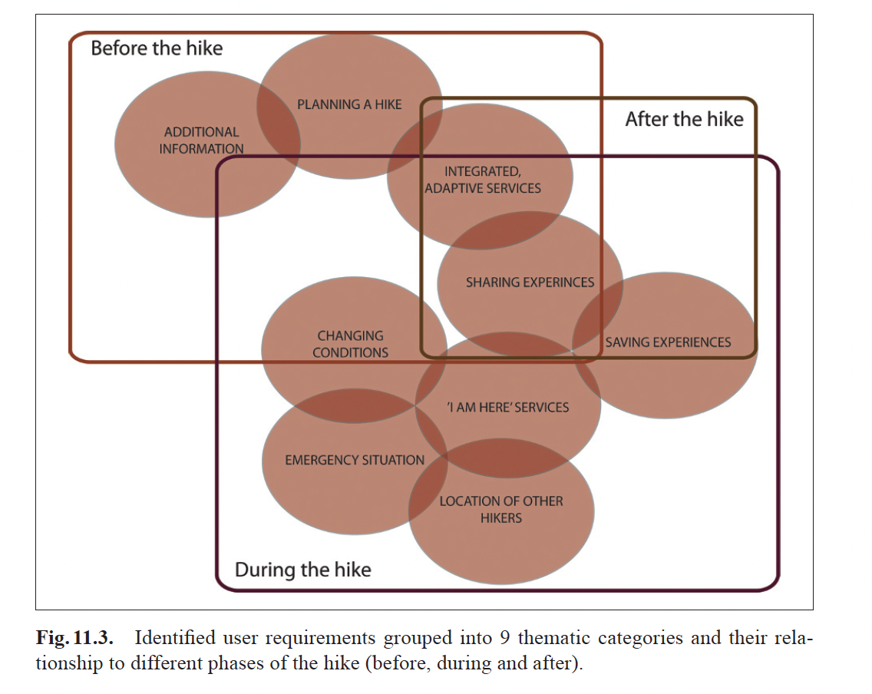

Fig 2. shows different hikers’ requirements during the different stages of the hike (Annu-Maaria Nivala et al., 2009)

## After the hike:

This stage is focused on blogging, reporting and sharing accounts of the hiking experience. This occurs after completing the experience and is usually at home or a café or a hotel, which is a considered a geographically stable location and will most likely have a stable internet connection, and good signal coverage. This digital connection is usually done asynchronously.

# Park/trail managers and the use of digital technology/ motivations/ information they would like

The use of digital technologies can help facilitate the management, maintenance and control of trails and parks. Given the vast size of the trails and parks, which can span across different cities, it can be challenging trying to effectively manage such areas. According to Lukovic et al (2019), the use of GPS enables smartphones, interlinked databases and high-performance computing can enhance the performances of and management of parks through the use of data gathering, public engagement and monitoring. There are three different technologies that can be investigated in regards to park management (Lukovic et al, 2019); the use of Geographic Information System (GIS) coverage and application, the use of community-based information on protected areas with emphasis on wildlife and different ecological websites such as NATURA 2000 and EMERALD with information on flora and fauna (specifically in Europe).

## GIS coverage and application:

GIS can be used in a variety of ways to; plan/design a park, operate a park, enhance/maintain a park using data driven performance and to crowd source information. Based on information gathered from govloop (https://www.govloop.com/), there are four successful US state parks examples that have used GIS for the above-mentioned reasons.

### Planning and Engineering:

The Los Angeles County has 3,024 open spaces that cover 900,000 acres, however most of this space is located in the mountains and is therefore not easily accessible by residents. However, using GIS data county officials and community members were able to gather and input data on each jurisdiction and the information was analyzed and assessed. This helped the government to propose a design that addressed the problems of the area.

### Operational Efficiency:

The Ohio Department of Natural Resources (ODNR), had significant problems in regards to map accuracies. However, by using GIS technology the staff members were able to provide their exact GPS locations along the park and create a more accurate digital map, with pull down menus to show trail accessibility (https://ohiodnr.gov/wps/portal/gov/odnr/go-and-do/outdoor/ohio-trails-app).

### Data Driven Performance:

Missouri State Park suffered from recurring flooding that wiped out large portions of hiking and bike trails. In order to overcome this situation, park staff had to go into the field after the water recedes with a GPS device and would manually sketch the damaged area. However, with the help of advanced GIS technology the park staff are now able to capture coordinates, photos and add observations and feed them directly into the app for more accurate data management (https://www.arcgis.com/apps/MapSeries).

### Civic Inclusion:

The final case study is in Minneapolis, the park was too large to manage and gather information. Thus, the state authorities opted for using GIS to gather information and feed it into the system. They have also enabled volunteers to provide information for data gathering in order to achieve the most accurate results

## Community based information:

This information is gathered through various tourist organizations and online forums (Lukovic, 2019). It not only helps promote the parks but it also provides managers with insights on various users’ feedback, requirements and observation. According to Lukovic (2019), the websites provide basic information, cultural information and georeferenced walking routes. This can help the managers locate the most favorable touristic locales and preferred routes.

## Digitization websites:

These websites include ecological information that helps organizations monitor and manage the conservation of wildlife and ecology (White D, 2009). These websites include NATURA2000 or EMERALD; which are websites with detailed information on flora and fauna in Europe. Using GIS and satellite technologies, park managers can generate detailed Cartographic maps of ecosystems, landscape and even real time location of tourists. Managers can collect information regarding tourist distribution using cameras, infrared sensors, GPS and pressure pads, which enable the managers to study tourist behavior (D’Antonio et al, 2010).

# Bibliography:

Amerson, K., Rose, J., Lepp, A., & Dustin, D. (2019). Time on the trail, smartphone use, and place attachment among Pacific Crest Trail thru-hikers. *Journal of Leisure Research*, *51*(3), 308–324. <https://doi.org/10.1080/00222216.2019.1680264>

Asimakopoulos, S., & Dix, A. (2017). Walking: A grounded theory of social engagement and experience. *Interacting with Computers*, *29*(6), 824–844. <https://doi.org/10.1093/iwc/iwx014>

Contributor, F., Monroe, J., Pulley, J. L., Grady-Pawl, S., Dorworth, R., & Johnson, N. B. (2021, September 16). *The Knowledge Network for Government*. GovLoop. Retrieved September 20, 2021, from <https://www.govloop.com/>.

Detour web and Mobile App. (n.d.). Retrieved September 20, 2021, from <https://ohiodnr.gov/wps/portal/gov/odnr/go-and-do/outdoor/ohio-trails-app>.

Gartner, G. F., & Rehrl, K. (2008). *Location Based Services and telecartography*. Springer.

Goldenberg, M., Hill, E., & Freidt, B. (2008). Why individuals hike the Appalachian trail: A qualitative approach to benefits. *Journal of Experiential Education*, *30*(3), 277–281. <https://doi.org/10.1177/105382590703000311>

Gómez, E., Freidt, B., Hill, E., Goldenberg, M., & Hill, L. (2010). Appalachian Trail hiking motivations and means-end theory: Theory, management, and Practice. *Journal of Outdoor Recreation, Education, and Leadership*, *2*(3). <https://doi.org/10.7768/1948-5123.1043>

HCI outdoors: Theory, design, methods and applications. (2020). *Human–Computer Interaction Series*. <https://doi.org/10.1007/978-3-030-45289-6>

Kyle, G., Graefe, A., Manning, R., & Bacon, J. (2003). An examination of the relationship between leisure activity involvement and place attachment among hikers along the Appalachian Trail. *Journal of Leisure Research*, *35*(3), 249–273. <https://doi.org/10.1080/00222216.2003.11949993>

Lum, C. S., Keith, S. J., & Scott, D. (2019). The long-distance hiking social world along the Pacific Crest Trail. *Journal of Leisure Research*, *51*(2), 165–182. <https://doi.org/10.1080/00222216.2019.1640095>

*Story map series*. arcgis.com. (n.d.). Retrieved September 20, 2021, from <https://www.arcgis.com/apps/MapSeries/index.html?appid=f1a3b64b0e3c4648bb268033d9b42681>.

Virginia Tech. (2018). *Using K-mode clustering to identify personas for technology on the trail* (dissertation).